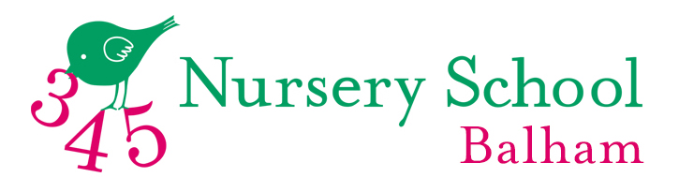
345 Balham Prospectus
Welcome to 345 Balham, an independent pre-school for children aged 2-5.

For over 25 years, 345 Balham (formerly Oaktree Nursery) has provided a safe, happy and creative atmosphere in which children can begin their lifelong learning journey. With a highly qualified staff and exceptional staff: children ratios, 345 Balham provides the right balance of nurture and adventure to ensure your child leaves nursery primed and excited to thrive at school.

Our approach
345 Balham is owner led and run by Jill Pearce and Katka Goodbody. Collectively, they have over 45 years’ experience in Early Years and are trained in Traditional and Montessori methods. They have developed a bespoke, child centric approach, where teaching is adapted to suit the way each child learns and to meet their particular needs. The curriculum is as broad as possible – offering the children a taste of innumerable experiences whilst covering The Early Years Foundation Stage as compiled by the DFES.

345’s teacher and PGCE trained staff know that progression in the ‘core’ skills of Personal, Social & Emotional Development and Physical Development are as important – and interlinked to – their development of Literacy, Mathematics, Understanding the World and Expressive Arts and Design. Taking a holistic approach that employs different environments, teaching styles and experiences, 345 ensures each child is reaching their unique potential academically and socially. This is all underpinned by nurturing the right mindset for learning - good critical thinking skills; plus the ability to listen, retain and apply the information and skills they have gained. Through this approach, children build their confidence to predict outcomes, work collaboratively and challenge situations.

Our Groups
Children are split into two groups, each one occupying their own classroom designed around their stage of development. Kits (for 2-3 year olds) is led by Miss Vicky, who is PGCE trained and a mother of three 345 Balham alumni. Squirrels (for 3-4 year olds) is led by Miss Ruth, a qualified teacher. Both are supported by experienced staff that maintain minimum 1:4 staff:pupil ratios in Kits and 1:5 in Squirrels.

Our activities
345 offers a structured morning’s activities. This gives the children a sense of security in the familiar pattern of each day. The children work individually and in groups, learning through play, exploration and investigation, and are introduced to letters and numbers at an early stage.

We seek to bring learning to life via creative, highly experiential activities. Forest school teaching occurs one day a week, and our expert peripatetic teachers help elevate our EYFS offering, offering a variety of classes from sport, to dance to Spanish and Music. These are all integrated into our curriculum without additional charge.

Additionally, teachers organise trips to complement children’s learning, including trips to local museums and Balham library. We regularly host members of the local community, such as police, fire brigade, nurses and doctors, so children can learn about the world around them.

Our Events
The creativity and calibre of our events is a source of pride for the staff and the children. Our self-composed musical Nativity, End of Term Play, Art Shows and Sports Days are much loved annual events. We also have termly informal concerts, science and music workshops, and bring your parent to school days.

Our location
345 Balham is situated Ramsden Hall, part of Balham Baptist Church. We have two classrooms designed to suit each years’ needs and capabilities, and two private outdoor spaces, focusing on imagination and physical development. We have a professional Dance Studio, fully equipped hall for music, and the child-friendly Ella’s café all on site. Located in the heart of Balham, we are well served by public transport, and local amenities such as the Library, and Wandsworth and Tooting Commons, which we each visit once a week.

Our child and parent-centric approach
We know that the best learners are happy learners, so everything in our onboarding is designed to make children feel happy, safe and confident. We always start with a home visit from Katka and Jill, engaging with your child’s interests and ensuring you both feel your child feels comfortable and excited about their start. We offer an ‘easing in’ process of 3 mornings a week for the first term. Upon joining, parents are updated daily on their child’s progress via video, pictures and teacher led commentary. We organise Parent’s Evenings in the Autumn and Spring terms. We are also always available to discuss any aspect of a child’s development, from SEN needs to school choices, in which we are seasoned experts.

We know from personal as well as professional experience that your child’s nursery needs to work for the whole family. Alongside our standard hours, we offer additional services of daily Breakfast Club (8.30am start), Lunch Club and after school clubs, which run until 3.15pm. Please contact Jill at jill@345nurseryschool.com to discuss your specific needs.

Talk to us
We have excellent relationships with all the primary schools in the area and are happy to assist parents in making the important choice of where to send their children after 345 Balham.

We hope this gives you an insight into life at 345 Balham, and we very much hope to welcome your children to life here at 345 Balham.

Jill Pearce and Katka Goodbody
Headteachers, 345 Balham
020 8166 5932
345NurseryBalham.com

